Google Classroom Information for Parents

Logging into Google Classroom:

Web Browser: classroom.google.com

Device: Classroom Application

- Username: studentfirstname.studentlastname@aveleysc.wa.edu.au
- Password: Set by your child (see FAQs on resetting passwords below)

N.B The username may have a number after the last name and your child will know this e.g if there is more than one student in a WA public school called John Smith the students username may be john.smith1@aveleysc.wa.edu.au

Information relating to Devices:

Google Suite (google classroom, docs, sheets and slides) can operate on any device. It can be installed as an application on any phone or tablet, or run as a web browser on any computer or laptop. All students enrolled in ZuluDesk have this suite of applications installed on their iPads.

Google Classroom Home Screen:

Below is an example of a Google Classroom homepage. There is a “card” for each class that your child is enrolled in.

- Click the title of the class to go directly to that class.
- Click the folder icon in the bottom-right of each card to go directly to the folder for that class in Google Drive.
- Unenrol: DO NOT unenrol from a Class unless your teacher has instructed you to do so!
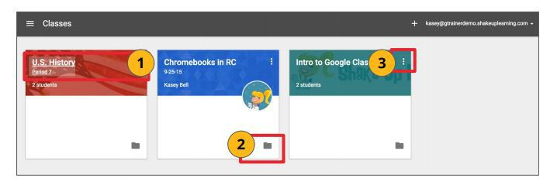

Navigating Classwork:

- The Stream is where students can view and access announcements, assignments, discussion topics, and comments. If enabled by the teacher, students can also add posts and leave comments. Class comments are viewable by the teacher and all students in the class.

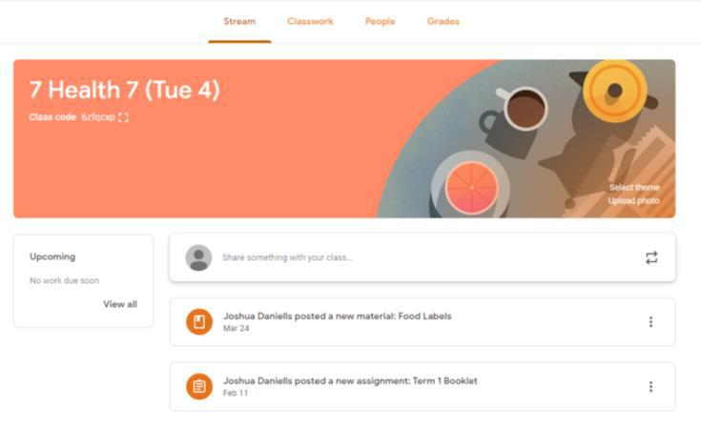

- Classwork is where all resources are uploaded as tasks for students to complete. Topics are set on the left hand side, allowing students and teachers to filter work by topic.
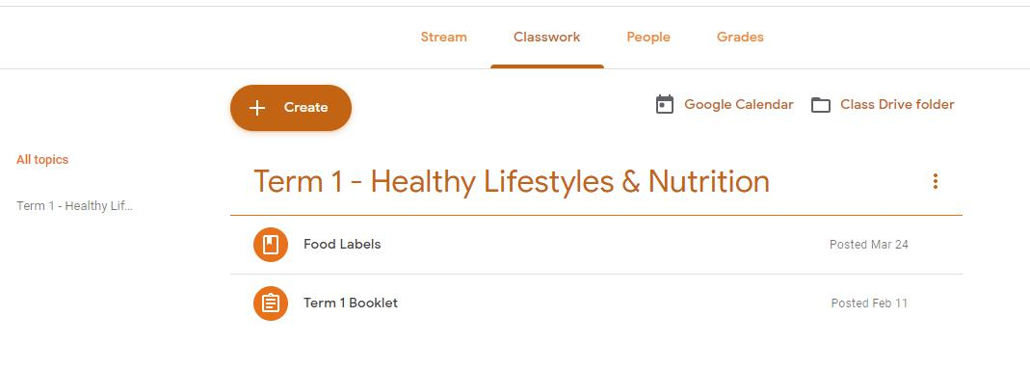

Google FAQs:

- Do I have access to google classroom as a parent?

G-Suite (including google classroom) access is only provided for staff and students within the Aveley Domain. At this stage parents do not have their own login details.

- My child is logged in but cannot see their classes, what do I do now?

Firstly, check that your child is logged in with their aveleysc.wa.edu.au google email and not their personal email. You can do this by clicking on the initial in the top right corner and check which account is logged in – see image below.

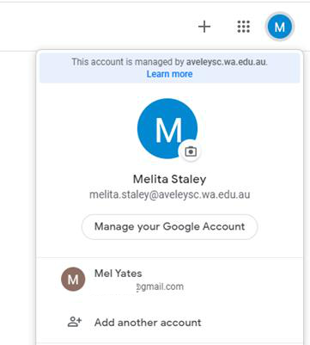

If you have checked that you are logged in correctly, please email
Aveley.sc.generalenquiries@education.wa.edu.au

- My child has forgotten their password, who do I contact?

Please contact Aveley.sc.generalenquiries@education.wa.edu.au to have their google password reset.

